**Record declaration:**

**To change something inside the record:**

**If you want to change the record value by using its own values, then we will use this method: Here point is changing its value by adding its own value.**

**A way to declare record with another name:**



**Here point is the struct, but we change its name from struct to origo.**

**Here are some other implementations as well.**

**Some other implementations:**

**Simplify function for Q struct:**



**This is the function to just convert 2 numbers into rational struct.**



**Arrays:**

If you want to declare the array you should have to write through this way:

Otherwise, you will receive this error.

There are only 2 built-in functions for trees:

* Size to get the size of the array but it will only work for array name not for this {1,2,3,5}. Otherwise, this error.

* And for indexing you can use subscripts with dot. MyArray.[2] to get the value at 3rd index. Like in list (!!).

Note : You can implement all the list functions by just converting the array into list by using comprehension transformation.

In comprehension we use (<-:) this sign for arrays.

Algebraic Data Types:

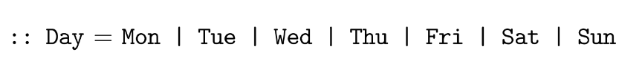

This is the implementation of making algebraic data types. Here “|” this symbol is just used to make another possibility of new value.

**Trees:** This is the way through which we make the trees:

**Here Node a is the root and (Tree a) is the left and right child of the root. This shows that this tree is binary.**

**To get the size or length of the tree:**

**This will calculate the number of nodes in the tree.**

**To get the height or depth of the tree.**

**It will calculate the levels within the tree.**

In this example we are sorting the array with the help of tree.(check the last page of register).

**In this example tree has two values a and b. a is for node and b is for leaf then he wrote a function to calculate the sum of leaves.**

**Different types of Trees:**

**Abstract Data Types:**

**This is the example and implementation of abstract data type.**

**Please remember to initialize the abstract data type we use:== and in algebraic data type we use ( = && also use this | ) . synonyms.**

* **THINGS TO REMEMBER:**

**Instances && Classes:**

**Some easy examples: (Don’t forget to add preConditions ). There are also some examples of making instances by using words like in the first case we use increment (++) to increase the element by 1.**

**Before that I discuss unary operators but to declare binary operators, we use this method this one is little bit different here you can also see the use of switch case.**

**Classes:**

**This is the method to make a class.**

**Rataional Struct is very important: please remember that.**

**Things to remember in complex number struct:**

**Single tree -> this tree has only 1 branch.**

**MAP Class:**

**-> Just view the last slides of the map class for backup.**

**QUIZES TO REMEMBER:**

